
SchoolHub

Capstone Portfolio Template 2026-2027
Team Code: W025014
IATS: El Sewedy
Grade: Wheeler
Team Members:
 |  |  | Name | St. Code
1- |  |  | Uotham Samir Nasim Boules | 525050
2- |  |  | Malk Mohamed Elsayed Mahmoud | 525084
3- |  |  | Yassen Abdullah Fathy Abdallah | 525048
4- |  |  | Malek Gamil Elsayed Hussein | 525030
5- |  |  | Youssef Ahmed Fathy Abd-El-Qader | 525051
6- |  |  | Abdelrahman Emad Al din Magdy Mahmoud Mady Yakot | 525021

Supervised by:
Eng. Marwa Imam
Eng.

ABSTRACT

Pet Finder is a mobile application designed to find lost dogs, cats, parrots, hamsters, iguanas, spiders and our other little friends that we love so much.
It was created as a part of portfolio with a view to show an easy, fast and effective way of using just one app for searching lost pets instead of making posters and posts in various social networks.

Introduction
(What is the challenge or problem your project will solve?
Summarize the challenge presented to your team. This will be your starting point for understanding the problem.
What are the roles of each team member, describe how these roles will be rotate?
List all team members and their responsibilities (e.g., researcher, designer, tester).)
What is the challenge or problem your project will solve?
The challenge we aim to address is the time-consuming and often ineffective process of finding lost pets. Traditional methods, such as posting flyers and sharing on social media, can be inefficient and limit the reach of the search. This project seeks to streamline this process by providing a centralized platform for reporting lost pets and connecting them with potential finders.
What are the roles of each team member, and how will these roles be rotated?
Our team comprises of the following members:
- [Team Member 1 Name]: Researcher and Designer
  - Responsible for conducting market research, identifying user needs, and creating the user interface and user experience (UI/UX) design.
- [Team Member 2 Name]: Developer
  - Responsible for the development and implementation of the mobile application, including backend and frontend development.
- [Team Member 3 Name]: Tester
  - Responsible for testing the application's functionality, usability, and performance to ensure a seamless user experience.
To foster collaboration and skill development, we will periodically rotate roles among team members. This rotation will allow each member to gain a comprehensive understanding of the project and contribute to different aspects of the development process.

Table of Contents
Section I: The problem background. 4
1.1 Sustainable Development Goals (SDGs) addressed 5
1.2 Empathize 6
Section II: Ideas and solutions 7
2.1 Define 8
2.2 Task Review: 8
2.3 Problem Statement: 8
2.4 Prior Solutions: 8
2.5 Ideate: 10
2.6 Problem Solution: 10
2.7 Our Selected Solution: 10
2.8 Solution Advantages & Disadvantages: 10
Section III: Experiment ideas and solutions 12
3.1 Task Review: 13
3.2 Methods used in Requirement Gathering: 13
3.3 Use Case Diagram: 13
3.4 Activity Diagram: 14
3.5 Sketches: 15
3.6 Linkable Prototype 15
3.7 Test and Evaluate: 16
3.8 Refine the design. 19
Section IV: Analyzing and communicating 20
4.1 Recommendations 21
4.2 Learning Outcomes 22
Competency Related: 22
4.3 Communication 23
4.4 References 24
Section V: Business Model Canvas Template 25

Section I: The problem background.

Sustainable Development Goals (SDGs) addressed
Connecting to SDGs
- Which Sustainable Development Goals (SDGs) are related to your project?
Select the SDGs that your project supports (e.g., Clean Energy, No Poverty), write a summary for the connection.
In this chapter, we will discuss Sustainable Development Goals that our project supports and how this project can help in sustainable development.
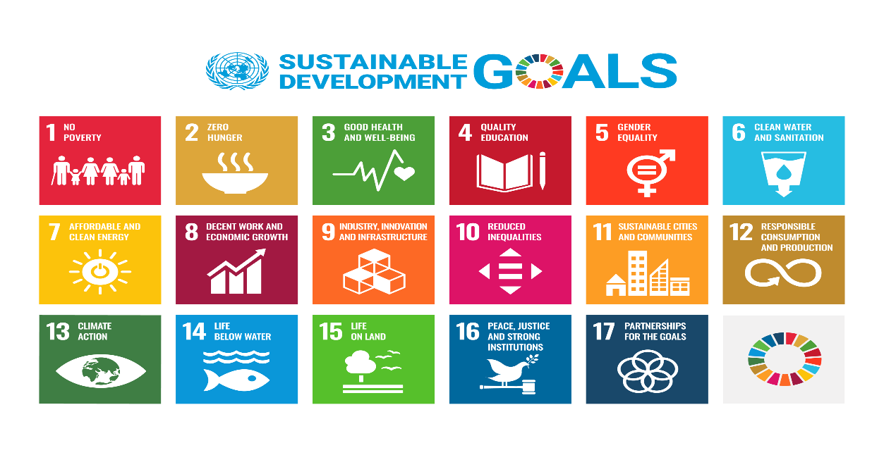

•SDG’s addressed:
- Goal 8: Decent Work and Economic Growth
- Goal 11: Sustainable Cities and Communities

1.2 Empathize
- Who are the users you are designing solution for?
Describe the people who will benefit from your solution (e.g., students, farmers, community members, customers).
- What are their needs and challenges?
List the problems these users face that your project will solve.
Who are the users you are designing the solution for?
The primary users of the Pet Finder app are:
- Pet Owners: Individuals who have lost their pets.
- Community Members: People who have found lost pets or are interested in helping.
- Animal Shelters: Organizations that can assist in the search and rescue of lost pets.
What are their needs and challenges?
The needs and challenges faced by these users include:
- Pet Owners:
  - Rapidly spreading information about the lost pet to a wide audience.
  - Efficiently coordinating search efforts with the community.
  - Accessing timely updates and potential leads.
- Community Members:
  - Easily reporting sightings of lost pets.
  - Quickly connecting with pet owners to reunite lost pets.
- Animal Shelters:
  - Collaborating with pet owners and the community to increase the chances of finding lost pets.
  - Leveraging technology to streamline their operations and improve efficiency.
Empathy Map

Section II: Ideas and solutions

Define
What is the final problem statement for your project?
Summarize the key problem that you will focus on solving.
What impact will solving this problem have on users and the market?
Describe how your solution will make life better for users and help the job market or industry

Task Review:
In this chapter, we will discuss problem definition, Prior solutions and our selected solution
What are some possible solutions to the problem?
List different ideas your team has come up with to solve the problem.
Have any similar solutions been tried before?
Research and explain other solutions that have addressed the same problem.
Why is your solution the best option?
Explain why your solution is better or more effective than others.
What will your prototype look like?
Draw or describe the design of your prototype.
How will you test your prototype?
Describe the steps you will take to test whether your prototype works as expected.
What materials do you need to build your prototype?
List the materials and their costs for building your prototype.

Problem Statement:

The core problem we aim to solve is the inefficiency and stress associated with

finding lost pets. Currently, individuals often rely on traditional methods like posting flyers and social media, which can be time-consuming, ineffective, and limited in reach.
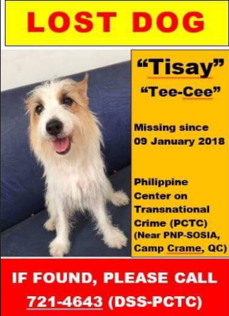


What impact will solving this problem have on users and the market?
By providing a centralized, efficient, and user-friendly platform for reporting lost pets and connecting with potential finders, we expect the following impacts:
- Improved User Experience:
  - Reduced stress and anxiety for pet owners during a difficult time.
  - Increased chances of reuniting lost pets with their owners.
  - Simplified the process of reporting lost pets and helping in the search.
- Market and Industry Impact:
  - Potential for partnerships with animal shelters and veterinary clinics to expand the app's reach and services.
  - Opportunities for monetization through premium features or advertising.
  - Positive impact on the animal welfare community by promoting responsible pet ownership and encouraging community involvement.
How will your solution make life better for users and help the job market or industry?
Pet Finder will make life better for users by:
- Saving time and effort: The app will streamline the process of reporting lost pets and searching for missing animals.
- Providing peace of mind: The app will offer a sense of hope and reassurance to pet owners during a stressful time.
- Strengthening community bonds: The app will foster a sense of community and encourage people to help each other.
For the job market and industry, Pet Finder has the potential to:
- Create new job opportunities: The development and maintenance of the app will require various technical and non-technical skills.
- Stimulate innovation: The app can serve as a platform for further innovation in pet tracking and recovery technologies.
- Contribute to the growth of the pet care industry: By increasing awareness of pet loss prevention and recovery, the app can contribute to the overall growth of the pet care industry.

Similar Solutions:
- Solution 1: Pet Tracker System
A networked location aware pet tracking and logging application implemented using motes and sensors. (1)
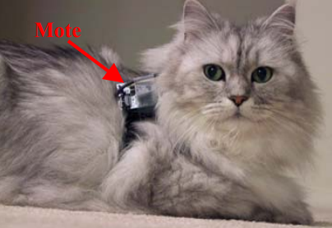

Advantages | Disadvantages
Very precise and accurate | High Cost  Hardware Requirements

- Solution 2: Pets Finder Application
A Social Media App Help Pet owner to publish Lost Pet Information and Communicate to Pet Finder.
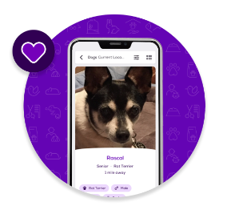
Advantages | Disadvantages
Low Cost | Require more time for finding pets

Ideate:

Problem Solution:
The solution is nice and easy-to-use product both for the owners and for those who help with finding pets, as they are an important link in a chain of a successful
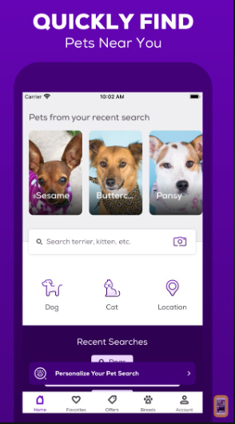
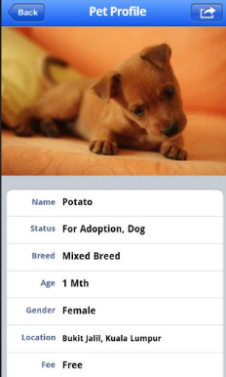
reunion.

Our Selected Solution:
A Social Media App Help Pet owner to publish Lost Pet Information and Communicate to Pet Finder.
Creative additions:
- Adaption for pets,
- Advices foe how to keep your pet safe.

Solution Advantages & Disadvantages:

Advantages | Disadvantages
Low Cost | Require more time for finding pets

2.9 Prototype Design:
Our prototype will be a mobile app with the following features:
- User Profile: Users can create profiles to share information about themselves and their pets.
- Lost Pet Report: A form to report a lost pet, including details like the pet's breed, color, and last seen location.
- Community Feed: A feed where users can share posts about lost and found pets, as well as safety tips.
- Notification System: Real-time notifications for users about relevant updates and alerts.
- Map Integration: A map to visualize the location of lost pets and potential sightings.
2.10 Prototype Testing:
To test our prototype, we will conduct user testing with a diverse group of individuals, including pet owners, community members, and animal shelters. We will evaluate the following:
- Usability: Is the app easy to navigate and use?
- Functionality: Do all features work as intended?
- Effectiveness: Does the app help users find lost pets efficiently?
- User Satisfaction: Are users satisfied with the app's overall experience?

2.11 Materials and Costs:
To build our prototype, we will need:
- Development Tools:
  - IDE (e.g., Android Studio, Xcode): Free
  - Programming Languages (e.g., Java, Kotlin, Swift): Free
- Design Tools:
  - Figma, Adobe XD: Free or subscription-based
- Server Hosting:
  - Cloud-based services (e.g., AWS, Google Cloud): Varying costs based on usage
- Testing Devices:
  - Smartphones and tablets: Varies based on device and quantity
While the initial development costs may vary, the ongoing maintenance and hosting costs can be relatively low, especially if we leverage free or low-cost cloud-based solutions.

2.12 Preliminary Feedback
- What feedback did you receive from the panel?
List feedback you received from the panel about your project.
- What changes did you make based on the panel’s feedback?
List any improvements you made to your project after getting feedback.

Section III: Experiment ideas and solutions

Task Review:
In this chapter, we will discuss initial system requirements using Use Case and Activity Diagrams. Also describe each Use Case of the system.

Methods used in Requirement Gathering:
- Interviews or Survey: 50 person of pet owners
- Brainstorming:
- User Observation:

Use Case Diagram:
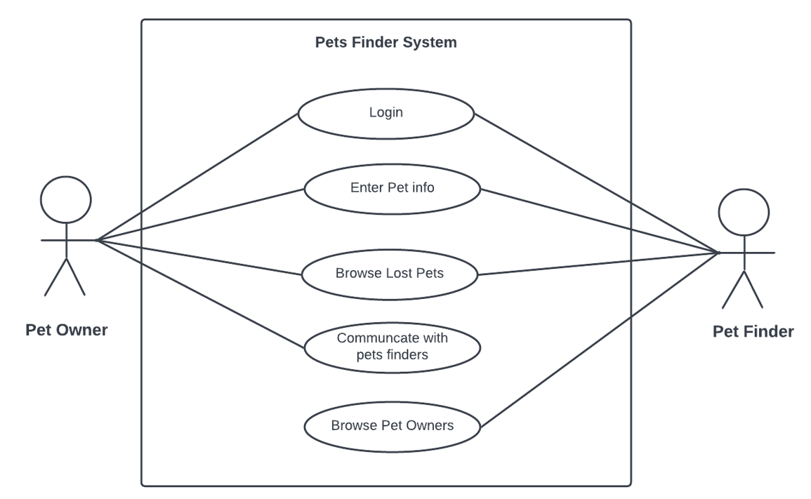
Use Case Description:

Activity Diagram:
First Case: Pet Owner
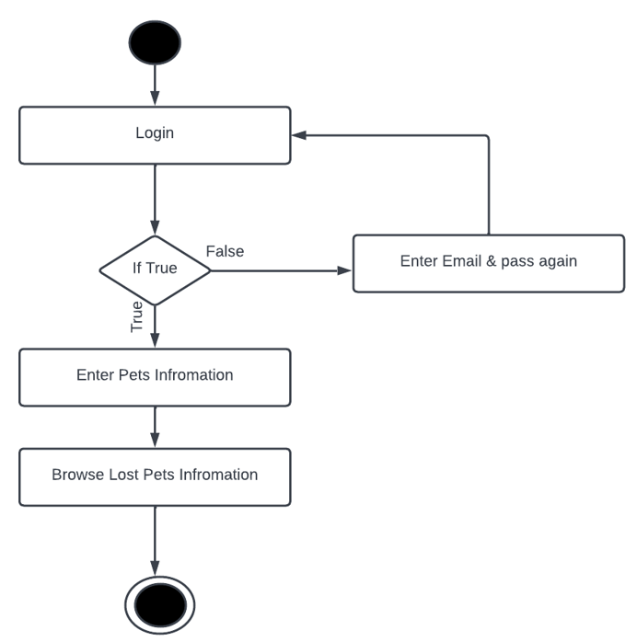
Activity Diagram Description:
- User login to the system, IF login success:
- User logged-in the system.
- IF not, system ask to register.
- If user logged-in, user can enter pet’s information and browse lost pet’s information.

3.5 Sketches:
Design the Prototype
- Draw or describe the final design of your prototype with dimensions.
Draw or describe the final version of the design for your prototype.
- What is the final materials list needed to build your prototype?
Write the final material list and their costs for building your prototype.
- What challenges do you expect during testing?
Write down any challenges you think you might face when testing your prototype.

3.6 Linkable Prototype
Prototype Link :

Registration Screen: Where the user will enter his personal information needed to run the application in the way that is designed for.
- His name
- Email Address
- Phone Number
- Country
- Location
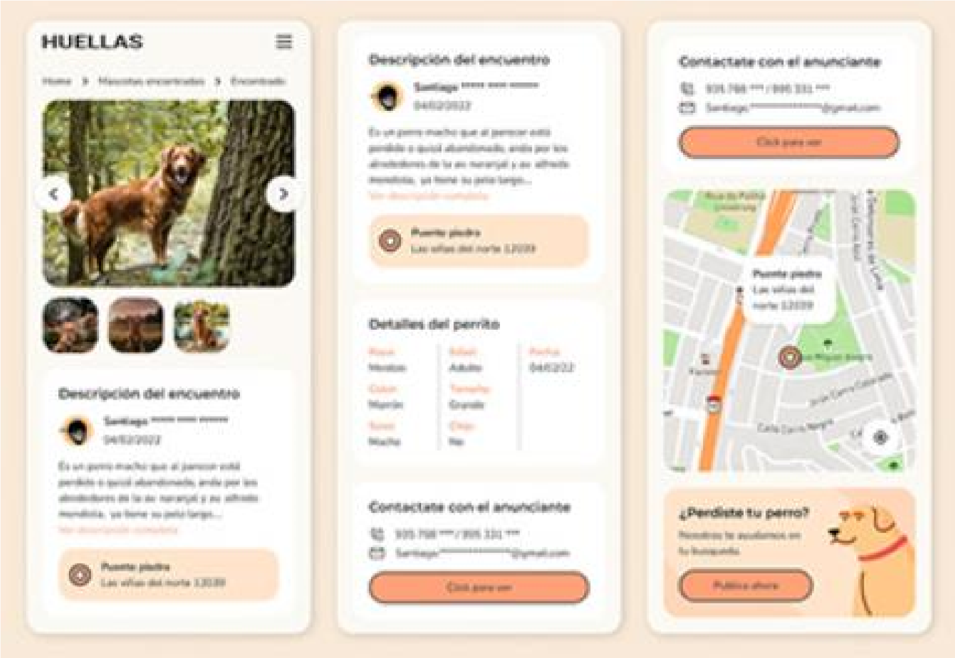

Building the Prototype
- What challenges did you face during building the prototype? How did you overcome them?
Write down any challenges you faced during building your prototype.

3.7 Test and Evaluate:

Use Cases: For example (but not limited): (1)
- Check the Login functionality
- Check the Registration functionality
- Check the Payment functionality
- Check the Search functionality 5. Check the Shopping functionality Test Cases:
Test  Case  ID | Test Case Description | Test Steps | Test Data | Expected Results | Actual Results | Pass/Fail
TC01 |  |  |  |  | As or Not as  Expected | Pass or Not Pass
TC02 |  |  |  |  | As or Not as  Expected | Pass or Not Pass

- What tests did you run on your prototype?
List the steps you followed during testing.
- What feedback did you receive from testing?
Summarize what you learned from testing and how users responded.

3.8 Survey and Evaluation:

Who is your target audience to fill the survey?

Number of survey respondents?

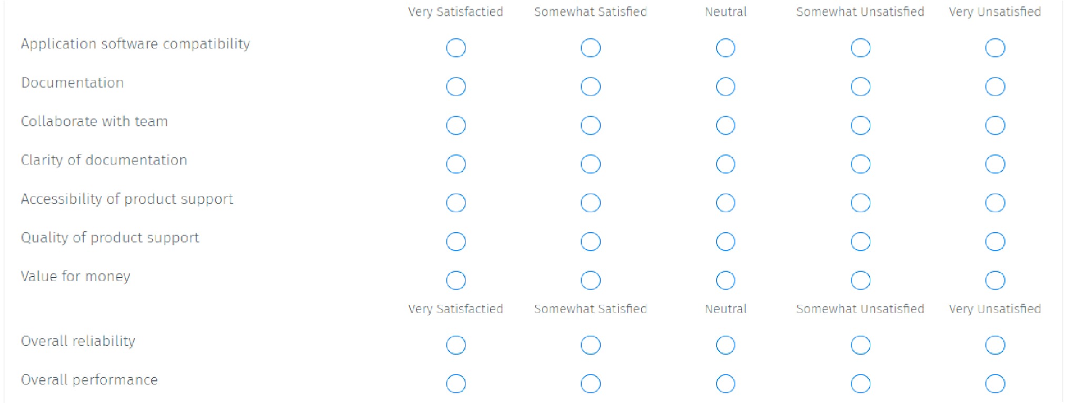
Software application Survey:

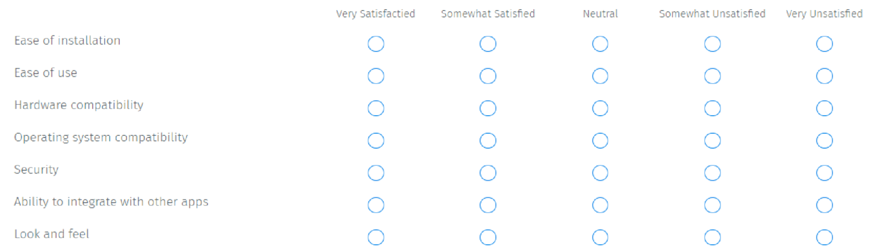

Refine the design.
Provide a visual representation of your data and results.
Include a chart, graph, or any visual to display your results.
How did you improve your prototype based on testing?
Write down changes you have made to improve your design.
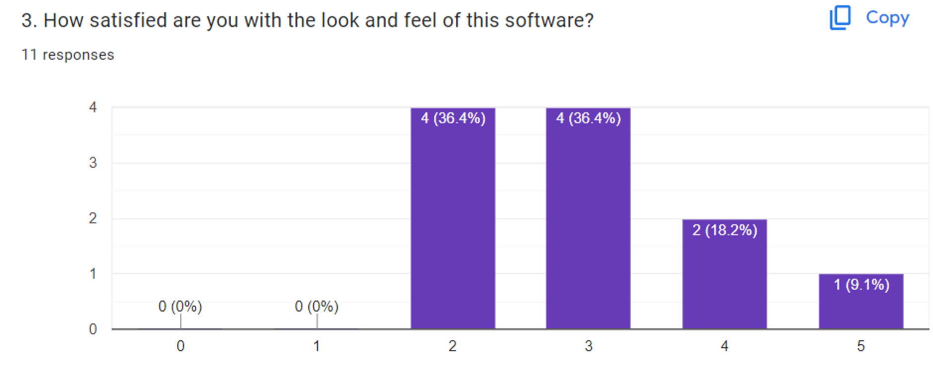
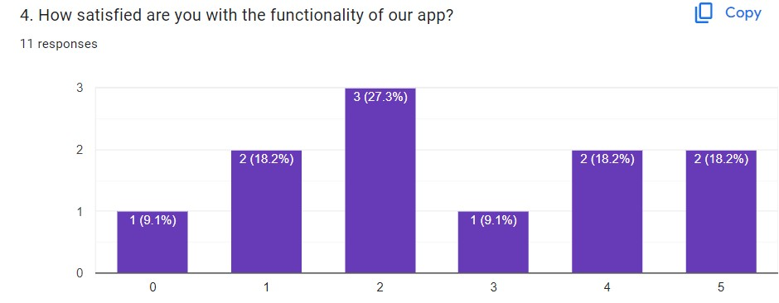

Survey
Results:

Section IV: Analyzing and communicating.

4.1 Recommendations
What recommendations do you have for future work in this area?
This includes recommendations on the prototype itself and/or the real life application of the project idea.
What would you tell another team who wanted to start where you stopped on your solution to help them?

4.2 Learning Outcomes
Transferred academic, Technical, and key Competences:
- Which competences did you use as related to your Capstone? Explain how each competence was used in your Capstone?
Write a brief summary of how did you use the knowledge and skills learned in different competencies in the capstone project.

Competency Related:
▪ Wireframe:
- Study Use Case Diagram
- Study Activity Diagram
3. Study Requirements Gathering
• Testing:
- Test Scenarios
- Test Cases

Story to communicate:
- What is the story behind your project?
Write a brief summary of your project’s journey, from problem to solution.
- What did your team learn from this project?
Reflect on the skills you gained and the lessons learned throughout the project.
- How did your project impact your users and the market?
Write about the positive effects your project had on users and the broader market.

4.3 Communication
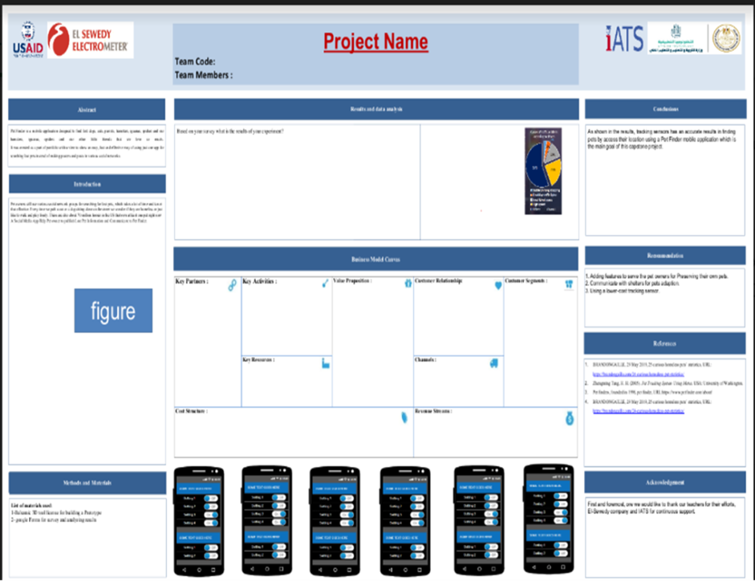

4.4 References
- List your sources in APA format as follows:
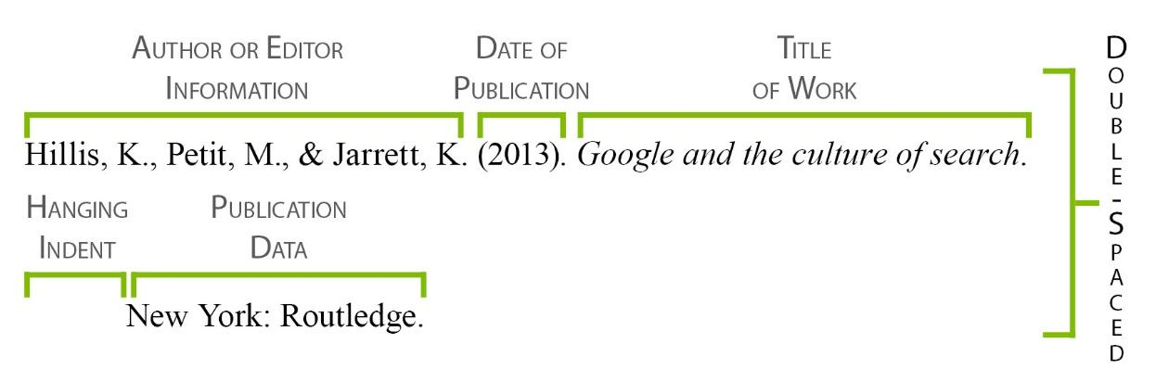

References:
- BRANDONGAILLE, 29 May 2019, 25 curious homeless pets’ statistics, URL: https://brandongaille.com/24-curious-homeless-pet-statistics/
- Zhengming Tang, H. H. (2005). Pet Tracking System Using Motes. USA: University of Washington.
- Pet finders, founded in 1996, pet finder,
URL:https://www.petfinder.com/about/

- BRANDONGAILLE, 29 May 2019, 25 curious homeless pets’ statistics,
URL: https://brandongaille.com/24-curious-homeless-pet-statistics/

Section V: Business Model Canvas Template

